**Read Stream**

**Code:**

var fs = require("fs");

var data = '';

var readerStream = fs.createReadStream('file.txt'); //Create a readable stream

readerStream.setEncoding('UTF8'); // Set the encoding to be utf8.

// Handle stream events --> data, end, and error

readerStream.on('data', function(chunk) {

data += chunk;

});

readerStream.on('end',function() {

console.log(data);

});

readerStream.on('error', function(err) {

console.log(err.stack);

});

console.log("Program Ended");

**Output:**

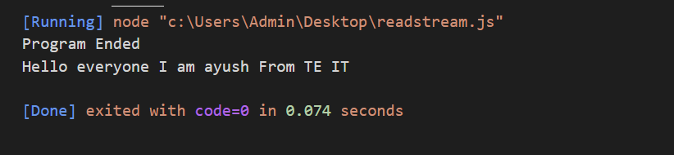

**Write Stream**

**Code:**

var fs = require('fs');

var readableStream = fs.createReadStream('file1.txt');

var writableStream = fs.createWriteStream('file2.txt');

readableStream.setEncoding('utf8');

readableStream.on('data', function(chunk) {

writableStream.write(chunk);

});

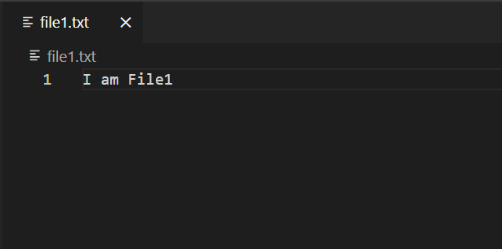

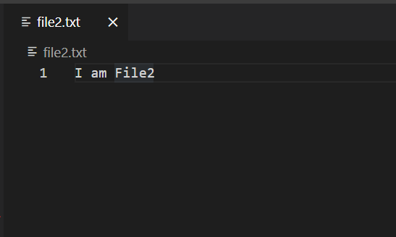

**Output:**

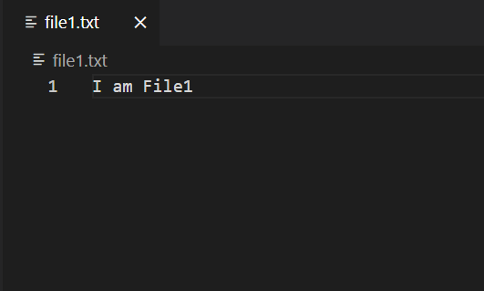

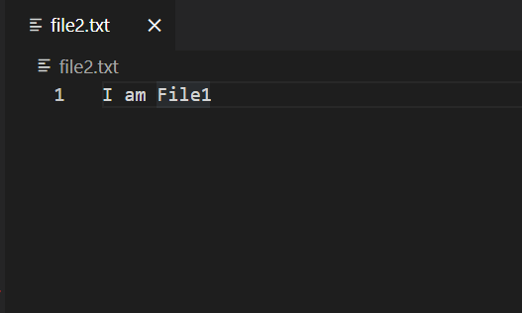

**Piping Stream**

**Code:**

var fs = require("fs");

var readerStream = fs.createReadStream('file1.txt');

var writerStream = fs.createWriteStream('ayush.txt');

readerStream.pipe(writerStream);

**Output:**

A file ayush.txt is created in the folder and the data of file1.txt is copied to it.

